**1.INTRODUCTION**

1.1 OVERVIEW OF THE SYSTEM

Dietary Planner is something that is now widely used in our time, people have become much more concerned about their health and fitness considering the increase of obesity, diabetical and heart related issues currently prevalent in our era.

With this paranoia people have started relying on diets and workouts to further improve their health and fitness. Diets are never constant and can vary from person to person so to find the correct diet isn’t as easy as searching some on the internet. People would usually consult a dietician for a personalized diet, which can be rather tedious and time consuming and people usually don’t rely on this method and usually just rely on online apps that give you a pre-planned diet which gives you a list of meals that can be consumed in the diet type (such as ketogenic, vegan, paleo etc) that you prefer.

1.2 PROBLEM DEFINITION AND OBJECTIVE OF THE PROJECT

In our time, everything can be accessed easily on our figer-tips because of our ever growing field of technology, and because of this, every field of study has been computerised and has been made to be easily accessible by everyone.

Our objective is to create a simple dietary planning system which will calculate your body mass index to find your body type and provides you tips on maintaining and reaching your ideal body type. And also provides you with the program to find meals in your preferred diet in a particular caloric value. Which will help the user track and maintain a proper caloric deficit which can help you cut body fat much easier.

**2.SYSTEM ANALYSIS**

* 1. INTRODUCTION

System analysis or study is an important phase of any system development process. The system is studied to the minutest details and analyzed. The system analyst plays the role of an interrogator and dwells deep into the working of the present system. The system is viewed as a whole and the inputs to the system are identified. The outputs from the organization are traced to through the various processing that the input phases through in the organization.

A detailed study of this process must be made by various techniques like interviews; questionnaires etc. the data collected by these sources must be scrutinized to arrive to a conclusion. The conclusion is an understanding of the system functions. This system is called existing system. Now the existing system is close study and problem solver tries to sort out difficulties that the enterprise faces.

* 1. IDENTIFICATION OF NEED

2.3 EXISTING SYSTEM

When creating a new system we should always strive to make the system more easily accessible and should rectify the drawbacks of the system before. The current system of planning a diet in rather tedious and time consuming, where people have to go to a dietician to understand and create a diet for them.

It is not possible for everyone to have the privilege and time to meet a dietician to create a personalised diet for the user. And our system is something that anyone can use to overcome said difficulty.

* 1. PROPOSED SYSTEM

The proposed application can make it much easier for the user to find the diet they need and can make it much faster and way more accessible for people from any background, our system provides people with an easy and understandable GUI and easily modifiable and secure system. And will provide the user with the complete macro breakdown of the meals in the diets and make it so that the user can specify the caloric value and view the meals under that certain caloric value.

2.4.1 BENEFITS OF PROPOSED SYSTEMS

The main advantage of the proposed system is user convenience. In this system, each module is created in a way were the user can view and access relevant data. Anyone can go through the system conveniently. And only authorized user can access the more secure application forms such as the diet data, and user info. The system is secured because the authorized users are provided with a unique id. Further improvement in the system is maintained by providing validation test at each field and also providing proper messages at each step. This helps in reducing the bugs and also improves the efficiency of the system.

2.5 FEASIBILITY STUDY

The feasibility study is carried out to determine whether the proposed system can be developed with available resources. A feasibility study is a test of system proposal according to its workability, ability to meet customer needs, and effective use of resources.

2.5.1 ECONOMIC FEASIBILITY

The given system can be developed under optimal expense with the available hardware and software. Besides it is a good economic to invest in such a kind of software from the project manager’s point of view as the benefits overweighs the costs. The resources needed to run the above project should be less in cost and highly reliable so that there might be no hanging and minimum level of expense to implement the software. Economic feasibility is the most frequently used method for evaluating the effectiveness of a candidate system. More commonly known as cost/benefit analysis the procedure is to determine the benefits and savings that are accepted from a candidate system and compare them with costs.

* + 1. TECHNICAL FEASIBILITY

The project requires the system to be functional and multi-user one. It should be based on specified technology. The system understudy must be portable and platform independent. It should be compatible with all kinds of existing system in industry and should not provide any overhead to the user. Technical feasibility senders on the existing system and to what extent it can support the proposed system. Updating and viewing the previous editions are tedious in the existing system. Implementation of proposed system does not require saving of the existing configuration of the system.

* + 1. BEHAVIOURAL FEASIBILITY

People are inherently resistant to change, and computers have been known to facilitate change. An estimate should be made of how strong a reaction the user staff is likely to have toward the development of a computerized system. [t is common knowledge that computer installations have something to do with turnover, transfers, retraining, and changes in employee job status. Therefore, it is understandable that the introduction of a candidate system requires special effort to educate, sell, and train the staff on new ways of conducting business  In our safe deposit example, three employees are more than 50 years old and have been with the bank over 14 years, four years of which have been in safe deposit. The remaining two employees are in their early thirties. They joined safe deposit about two years before the study. Based on data gathered from extensive interviews, the younger employees want the programmable aspects of safe deposit (essentially billing) put on a computer. Two of the three older employees have voiced resistance to the idea. Their view is that billing is no problem. The main emphasis is customer service-personal contacts with customers. The decision in this case was to go ahead and pursue the project.

* + 1. OPERATIONAL FEASIBILITY

The present system is easily understandable and maintenance and working of a new system needs less human efforts. The proposed project is beneficial to the organization and is user friendly. The system is directly used by administrator and staff of the courier management system. So the system can be judged operationally feasible.

* + 1. HARDWARE AND SOFTWARE FEASIBILITY

Assessing technical feasibility includes evaluating the ability of computer hardware and software to handle workloads adequately. All current computer hardware the organization owns must be inventoried to discover what is on hand and what is usable. The systems analyst needs to work with users to determine what hardware will be needed. Hardware determinations can come only in conjunction with determining human information requirements. Knowledge of the organizational structure and how users interact with technologies in an organizational setting can also be helpful in hardware decisions. Only when systems analysts, users, and management have a good grasp of what kinds of tasks must be accomplished can hardware options be considered.

The development team visits the user and studies their system. They investigate the need for development in the given system. By the end of the feasibility study, the team furnishes a document that holds the different specific recommendations for the candidate system. It also includes the personnel assignments, costs, project schedule and target dates. The requirements-gathering process is intensified and focuses specifically on software. To understand the nature of the program to be built, the System Engineer (developer) must understand the information area for the software, as well as required function, its behaviour, performance and other systems it interfaces with.

* + 1. LEGAL FEASIBILITY

Legal feasibility study is to know if the proposed project conform the legal and ethical requirements.  It is important that the project or business is following the requirements needed to start a business or a project including business licenses, certificates, copyrights, business insurance, tax number, health and safety measures, and many more. There are some things to consider in legal feasibility study including ethical issues and some social issues. These issues are the privacy, nepotism, and accountability.

* + 1. SCHEDULE AND RESOURCE FEASIBILITY

It is also an essential part of a feasibility study. It includes questions regarding time required to complete the project, type and amount of resources required and dependent factors. It also takes care whether the project is interrupting any current business activity.

A project will fail if it takes too long to be completed before it is useful. Typically this means estimating how long the system will take to develop, and if it can be completed in a given time period using some methods like payback period. Schedule feasibility is a measure of how reasonable the project time table is.

* 1. SYSTEM SPECIFICATION

After the analyst has collected all required information regarding the software to be developed, and has removed all completeness, inconsistency, and anomalies from specification, he starts to systematically organize the requirements the form of an SRSdocument**.** The software developers refer to the SRSdocumentto make sure that they developed exactly what the customer requires. The SRS document helps the maintenance engineers to understand the functionality of the system.

2.6.1 SOFTWARE SPECIFICATION

A software requirements specification (SRS) is a description of a software system to be developed. It is modeled after business requirement specification, also known as a stakeholder requirement specification. The software requirements specification lays out functional and non-functional requirements and it may include a set of use cases that describe user interactions that the software must provide to the user for perfect interaction.

Software requirements specification establishes the basis for an agreement between customers and contractors or suppliers on how the software product should function (in a market-driven project, these roles may be played by the marketing and development divisions). Software requirements specification is a rigorous assessment of requirements before the more specific system design stages, and its goal is to reduce later redesign. It should also provide a realistic basis for estimating product costs, risks, and schedules. Used appropriately, software requirements specifications can help prevent software project failure.

The software requirements specification document lists sufficient and necessary requirements for the project development. To derive the requirements, the developer needs to have clear and thorough understanding of the products under development. This is achieved through detailed and continuous communications with the project team and customer throughout the software development process.

* + 1. TOOLS/PLATFORM

SUBLIME TEXT 3

It  is an amazing piece of software. To start, it is a clean, functional, and fast code editor. Not only does it have incredible built in features (multi-edit and vim mode), but it has support for plugins, snippets, and many other things.

Sublime Text is a versatile editor for programmers, but you don’t need to be one in order to use it, and you don’t need to configure it extensively to be productive—it’s an efficient tool out of the box. Hackers, however, will appreciate all the customization and extensibility opportunities. Sublime Text exposes its internals via an Application Programming Interface (API) that programmers can interact with using the Python programming language. An embedded Python interpreter is included in the editor. The embedded interpreter is useful to inspect the editor’s settings and to quickly test API calls while developing plugins.

SQLyog

SQLyog is the most powerful manager, admin and GUI tool for MySQL, combining the features of MySQL Query Browser, Administrator, phpMyAdmin and other MySQL Front Ends and MySQL GUI tools in a single intuitive interface. SQLyog is a fast, easy to use and compact graphical tool for managing your MySQL databases. SQLyog was developed for all who use MySQL as their preferred RDBMS. Whether you enjoy the control of handwritten SQL or prefer to work in a visual environment, SQLyog makes it easy for you to get started and provides you with tools to enhance your MySQL experience.

SQLyog allows easy access to frequently used SQL scripts. The script files can be stored as files from the SQLyog interface or link to an existing file anywhere where windows can access it - on a local drive or a shared network drive. The SQL scripts and the file links can be organized in folders and subfolders.

WAMP

Stands for "Windows, Apache, MySQL, and PHP." WAMP is a variation of LAMP for Windows systems and is often installed as a software bundle (Apache, MySQL, and PHP). It is often used for web development and internal testing, but may also be used to serve live websites.

The most important part of the WAMP package is Apache (or "Apache HTTP Server") which is used to run the web server within Windows. By running a local Apache web server on a Windows machine, a web developer can test web pages in a web browser without publishing them live on the Internet.

WAMP also includes MySQL and PHP, which are two of the most common technologies used for creating dynamic websites. MySQL is a high-speed database, while PHP is a scripting language that can be used to access data from the database. By installing these two components locally, a developer can build and test a dynamic website before publishing it to a public web server.

While Apache, MySQL, and PHP are open source components that can be installed individually, they are usually installed together. One popular package is called "WampServer," which provides a user-friendly way to install and configure the "AMP" components on Windows.

* + 1. HARDWARE SPECIFICATION

Processor : INTEL Core i3

Speed : 2.4 GHz

Memory : 500 GB

Hard Disk : 500 MB free space

Monitor : HP

Keyboard : 102

Operating System : WINDOWS

Front End : VISUAL BASIC 6.0

Back End : Microsoft SQL Server 2008

IDE :Visual basic 6.0, My SQL server 2008

**3.SYSTEM DESIGN**

3.1 INTRODUCTION

System design is an interactive process through which requirements are transmitted to a “blueprint” for constructing the software initial; the blueprint depicts a holistic view of software that is design is represented at a high-level abstraction a level that can be directly traced to specific data, functional and behavioral requirements. As design interaction occur subsequent refinement leads to design representation at a much lower level of abstraction. System design is a creative art of inventing and developing input, databases, offline files, method and procedures for processing data to get meaningful output that satisfy the organization objectives. Through the design phase consideration to the human factor, that is inputs to the users will have on the system.

Some of the main factors that have to be noted using the design of the system are:

* Practicability

System must be capable of being operated over a long period of time and must have ease of use.

* Efficiency

Make better use of available resources. Efficiency involves accuracy, timeliness and comprehensiveness of system output.

* Cost

Aim of minimum cost and better results.

* Security

Ensure physical security of data.

3.2 INPUT DESIGN

Input design is the process of converting user-oriented input to a based format. Inaccurate input data are the most common cause of errors in data processing. Errors entered by data entry operators can be controlled by input design.

The goal of designing input data is to make data entry as easy, logical and free from errors. When we approach input data design; we design the data source documents that capture the data and then select the media used to enter them into the computer.

User-friendly screen format can reduce the burden on end users, who are not highly proficient in computers. An important step in input design stage is a design of source document. Source document is the form in which the data can initially capture. The next step is the design of the document layout. In the layout organizes the document by placing information, where it will be noticed and establishes the appropriate sequence of items.

In our system, almost all inputs are being taken from the databases. To avoid adequate inputs we have to select necessary values from the databases and arrange it to the appropriate controls.

3.3 OUTPUT DESIGN

Computer output is the most important and direct source of information to the user. Efficient and intelligent output design improves the system’s relationship and helps user decision-making.

In the output design it is determined how the implementation is to be played for immediate need and also the hardcopy output. A major form of input is a hardcopy from the printer. Printouts should be designed around the output requirement of the user. Printers, CRT screen display are the examples for providing computer based output. The output design associated with the system includes the various reports of the table generations and query executions.

Output design is one of the most important features of the information system. The logical design of an information system is analogous to an engineering blueprint of an automobile. It shows the major features and how they are related to one another. The outputs, inputs and databases are designed are in this phase.

3.4 DATABASE DESIGN

Database design is one of the most important parts of the system design phase. In a database environment, data available are used by several users instead of each program managing its own data, authorized users share data across application with the database software managing the data as an entity.

Primary key is one of the candidate keys that are chosen to be the identifying key for the entire table.

Normalization is a process of organizing the data in database to avoid data redundancy, insertion anomaly, update anomaly & deletion anomaly.

Here are the most commonly used normal forms:

* First normal form(1NF)
* Second normal form(2NF)
* Third normal form(3NF)
* Boyce & Codd normal form (BCNF)

FIRST NORMAL FORM(1NF)

As per the rule of first normal form, an attribute (column) of a table cannot hold multiple values. It should hold only atomic values.

SECOND NORMAL FORM(2NF)

A table is said to be in 2NF if both the following conditions hold:

* Table is in 1NF (First normal form)
* No non-prime attribute is dependent on the proper subset of any candidate key of the table.

An attribute that is not part of any candidate key is known as non-prime attribute.

THIRD NORMAL FORM(3NF)

A table design is said to be in 3NF if both the following conditions hold:

* Table must be in 2NF
* [Transitive functional dependency](https://beginnersbook.com/2015/04/transitive-dependency-in-dbms/) of non-prime attribute on any super key should be removed.
* An attribute that is not part of any candidate key is known as non-prime attribute.

In other words, 3NF can be explained like this: A table is in 3NF if it is in 2NF and for each functional dependency X-> Y at least one of the following conditions hold:

* X is a super-key of table
* Y is a prime attribute of table
* An attribute that is a part of one of the candidate keys is known as prime attribute.

Boyce Codd normal form (BCNF)

It is an advanced version of 3NF that’s why it is also referred as 3.5NF. BCNF is stricter than 3NF. A table complies with BCNF if it is in 3NF and for every functional dependency X->Y, X should be the super key of the table.

* 1. DATA FLOW DIAGRAM

A data flow diagram (DFD) is a graphical representation of the "flow" of data through an [information system](https://en.wikipedia.org/wiki/Information_system), modelling its process aspects. A DFD is often used as a preliminary step to create an overview of the system without going into great detail, which can later be elaborated. DFDs can also be used for the [visualization](https://en.wikipedia.org/wiki/Data_visualization) of [data processing](https://en.wikipedia.org/wiki/Data_processing) (structured design).

A DFD shows what kind of information will be input to and output from the system, how the data will advance through the system, and where the data will be stored. It does not show information about process timing or whether processes will operate in sequence or in parallel, unlike a traditional structured [flowchart](https://en.wikipedia.org/wiki/Flowchart) which focuses on control flow, or a UML activity workflow diagram, which presents both control and data flows as a unified model.

RULES FOR DRAWING DATA FLOW DIAGRAM

* Each process should have at least one input and an output.
* Each data store should have at least one data flow in and one data flow out.
* Data stored in a system must go through a process.
* All processes in a DFD go to another process or a data store.

BASIC DFD SYMBOLS

The primitive symbols used in the DFDA are:

* External entity



The external entities are essentially those physical entities external to the software system which interact with the system by inputting data to the system or by consuming the data produced by the system. For example user of a system, Entities supplying data are known as sources and those that consume data are sinks.

* Process



The functions are using circles. Bubbles are annotated with the names of the corresponding functions. They convert data into information.

* Data Flow



A directed arrow or arc is used as data flow symbol that represents the data flow occurring between two processes, or between external entity and a process.

* Data Store



A data store represents logical files. Each data store is connected to a process by means of data flow symbol.

CONTEXT DIAGRAM

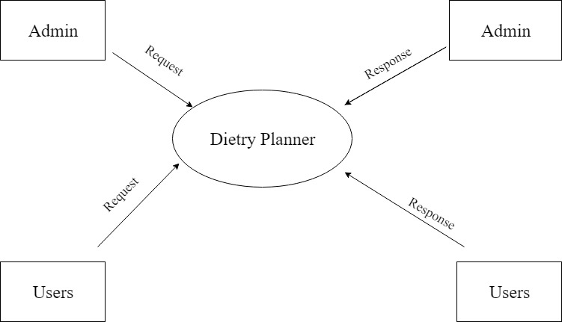

LEVEL 1 ADMIN

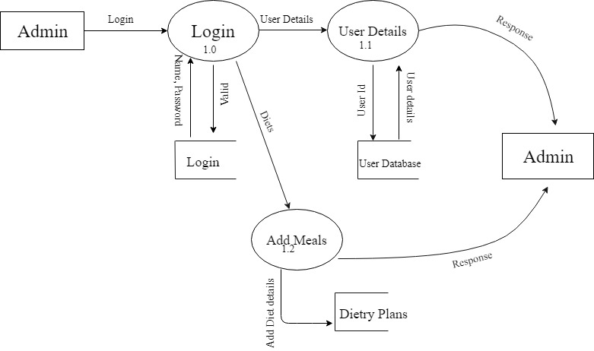

LEVEL 1 USER 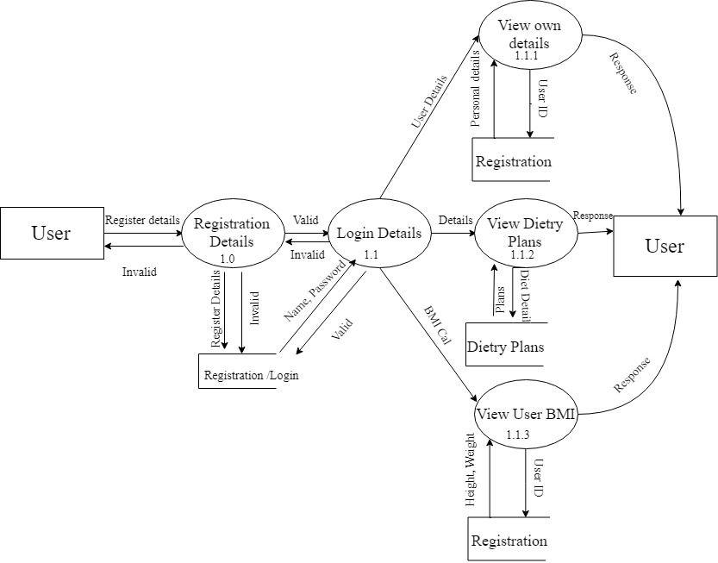

LEVEL 2 ADMIN

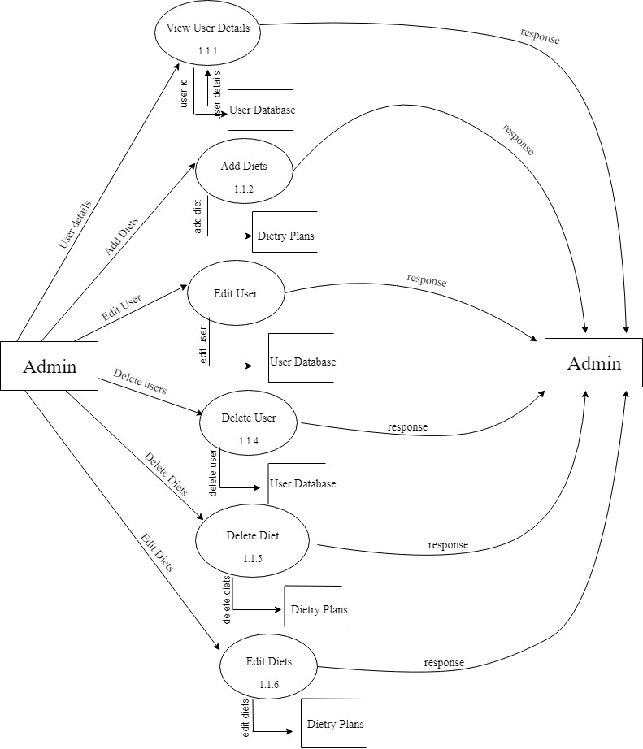

LEVEL 2 USER

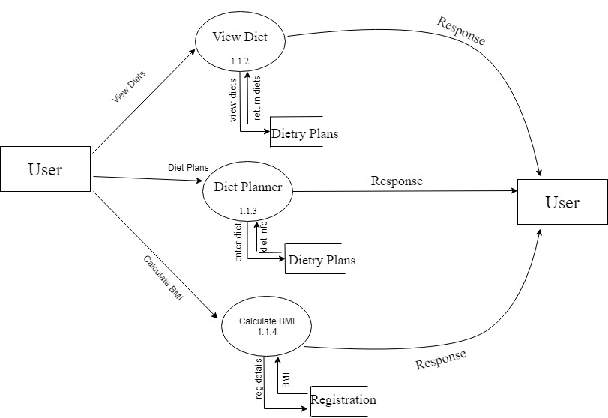

3.6 ER DIAGRAM

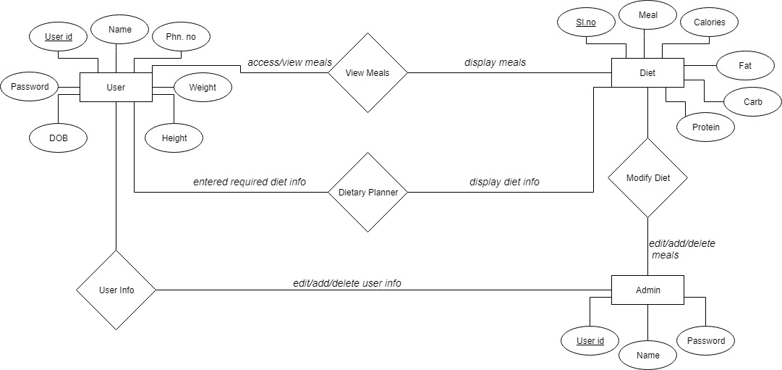

**4. SYSTEM DEVELOPMENT**

4.1 MODULE DESCRIPTION

Registration Module

Registration module is the first module which allows user to register their details in order gets access of the application. It consists of simple registration form, where the user details mobile number, height, weight and address are asked for entering which are stored in database server.

Dietary Module

It helps the user personalise their choices for meals under their specified diet, meaning they can choose the diet they want(eg. Ketogenic, Paleo, Vegan etc) and can enter the caloric value they want their meal to be under. This helps the user also find the macros of the meals they intend to add to their diet so they can keep track of their macros and caloric intake.

BMI Module

This module helps the user find their BMI(body mass index), and also provide them with the information on their body type and also tips on how to either maintain or reach a healthy body type.

4.2 SOURCE CODE

HEADER

<!DOCTYPE html>

<html lang="en">

<head>

<!-- Basic -->

<meta charset="utf-8">

<meta http-equiv="X-UA-Compatible" content="IE=edge">

<!-- Mobile Metas -->

<meta name="viewport" content="width=device-width, maximum-scale=1, initial-scale=1, user-scalable=0">

<!-- Site Metas -->

<title>Diet Planner</title>

<meta name="keywords" content="">

<meta name="description" content="">

<meta name="author" content="">

<!-- Site Icons -->

<link rel="shortcut icon" href="images/favicon.ico" type="image/x-icon" />

<link rel="apple-touch-icon" href="images/apple-touch-icon.png">

<!-- Bootstrap CSS -->

<link rel="stylesheet" href="css/bootstrap.min.css">

<!-- Site CSS -->

<link rel="stylesheet" href="css/style.css">

<!-- Responsive CSS -->

<link rel="stylesheet" href="css/responsive.css">

<!-- color -->

<link id="changeable-colors" rel="stylesheet" href="css/colors/orange.css" />

<!-- Modernizer -->

<script src="js/modernizer.js"></script>

<!--[if lt IE 9]>

<script src="https://oss.maxcdn.com/libs/html5shiv/3.7.0/html5shiv.js"></script>

<script src="https://oss.maxcdn.com/libs/respond.js/1.4.2/respond.min.js"></script>

<![endif]-->

</head>

<body>

<div id="loader">

<div id="status"></div>

</div>

<div id="site-header">

<header id="header" class="header-block-top">

<div class="container">

<div class="row">

<div class="main-menu">

<!-- navbar -->

<nav class="navbar navbar-default" id="mainNav">

<div class="navbar-header">

<button type="button" class="navbar-toggle collapsed" data-toggle="collapse" data-target="#navbar" aria-expanded="false" aria-controls="navbar">

<span class="sr-only">Toggle navigation</span>

<span class="icon-bar"></span>

<span class="icon-bar"></span>

<span class="icon-bar"></span>

</button>

<div class="logo">

<a class="navbar-brand js-scroll-trigger logo-header" href="index.php">

<img src="images/logo.png" alt="">

</a>

</div>

</div>

<div id="navbar" class="navbar-collapse collapse">

<ul class="nav navbar-nav navbar-right">

<li class="active"><a href="index.php">Home</a></li>

<li><a href="#about">About us</a></li>

<li><a href="reg.php">Register</a></li>

<li><a href="login.php">Login</a></li>

<!-- <li><a href="#footer">Contact us</a></li> -->

</ul>

</div>

<!-- end nav-collapse -->

</nav>

<!-- end navbar -->

</div>

</div>

<!-- end row -->

</div>

<!-- end container-fluid -->

</header>

<!-- end header -->

</div>

<!-- end site-header -->

FOOTER

<div class="footer-box pad-top-70">

<div class="container">

<div class="row">

<div class="footer-in-main">

<div class="footer-logo">

<div class="text-center">

<img src="images/logo.png" alt="" />

</div>

</div>

<div class="col-lg-3 col-md-3 col-sm-6 col-xs-12">

<div class="footer-box-a">

<h3>About Us</h3>

<p>We're a small company focused on providing tools and support for people who want to take control over their nutrition.</p>

<ul class="socials-box footer-socials pull-left">

<li>

<a href="#">

<div class="social-circle-border"><i class="fa fa-facebook"></i></div>

</a>

</li>

<li>

<a href="#">

<div class="social-circle-border"><i class="fa fa-twitter"></i></div>

</a>

</li>

<li>

<a href="#">

<div class="social-circle-border"><i class="fa fa-google-plus"></i></div>

</a>

</li>

<li>

<a href="#">

<div class="social-circle-border"><i class="fa fa-pinterest"></i></div>

</a>

</li>

<li>

<a href="#">

<div class="social-circle-border"><i class="fa fa-linkedin"></i></div>

</a>

</li>

</ul>

</div>

<!-- end footer-box-a -->

</div>

<!-- end col -->

<div class="col-lg-3 col-md-3 col-sm-6 col-xs-12">

<div class="footer-box-c">

<h3>Contact Us</h3>

<p>

<i class="fa fa-map-signs" aria-hidden="true"></i>

<span>77 Sheriff Street, Watford N.London 1021, England</span>

</p>

<p>

<i class="fa fa-mobile" aria-hidden="true"></i>

<span>

+44 7743 2346

</span>

</p>

<p>

<i class="fa fa-envelope" aria-hidden="true"></i>

<span><a href="#">support@foodfunday.com</a></span>

</p>

</div>

<!-- end footer-box-c -->

</div>

<!-- end col -->

</div>

<!-- end footer-in-main -->

</div>

<!-- end row -->

</div>

<!-- end container -->

<div id="copyright" class="copyright-main">

<div class="container">

<div class="row">

<div class="col-lg-12 col-md-12 col-sm-12 col-xs-12">

<h6 class="copy-title"> Copyright &copy; 2017 Food Funday is powered by <a href="#" target="_blank"></a> </h6>

</div>

</div>

<!-- end row -->

</div>

<!-- end container -->

</div>

<!-- end copyright-main -->

</div>

<!-- end footer-box -->

</div>

<!-- end footer-main -->

<a href="#" class="scrollup" style="display: none;">Scroll</a>

<section id="color-panel" class="close-color-panel">

<a class="panel-button gray2"><i class="fa fa-cog fa-spin fa-2x"></i></a>

<!-- Colors -->

<div class="segment">

<h4 class="gray2 normal no-padding">Color Scheme</h4>

<a title="orange" class="switcher orange-bg"></a>

<a title="strong-blue" class="switcher strong-blue-bg"></a>

<a title="moderate-green" class="switcher moderate-green-bg"></a>

<a title="vivid-yellow" class="switcher vivid-yellow-bg"></a>

</div>

</section>

<!-- ALL JS FILES -->

<script src="js/all.js"></script>

<script src="js/bootstrap.min.js"></script>

<!-- ALL PLUGINS -->

<script src="js/custom.js"></script>

</body>

</html>

CONNECT

<?php

$server="localhost";

$dbuser="root";

$password="";

$dbname="diet";

$con=mysqli_connect($server, $dbuser,$password,$dbname);

if($con){

echo " ";

}

else{

echo "Faliure";

}

?>

REGISTRATION

<?php

require_once 'connect.php';

if(isset($_POST["btn"])){

$name=$_POST["na"];

$password=$_POST["pass"];

$gender=$_POST["gen"];

$dob=$_POST["do"];

$address=$_POST["add"];

$ph_no=$_POST["ph"];

$height=$_POST["he"];

$weight=$_POST["we"];

$sql="select * from login where uname='$name'";

$result=mysqli_query($con, $sql);

if(mysqli_num_rows($result)>0)

{

echo "User already exists";

}else{

$sql="insert into login(uname, password, type, status) values('$name', '$password', 'user', '0')";

if(mysqli_query($con, $sql)){

$id=$con->insert_id;

$sql="insert into reg(user_id, name, gender, dob, address, ph_no, height, weight) values('$id','$name', '$gender', '$dob', '$address', '$ph_no', '$height', '$weight')";

mysqli_query($con, $sql);

}

else{

echo "Error Occured";

}

}

}

?>

<?php include_once 'header.php' ?>

<style>

body {

background-image: url("2.jpg");

}

</style>

<script>

function checkCharacter(inputtext) {

var letters = /^[A-Za-z]+$/;

if(inputtext.value.match(letters))

{

return true;

}

else

{

alert("Invalid Letters");

return false;

}

}

function lengthRange(inputtxt)

{

var userInput = inputtxt.value;

if(userInput.length >= 6)

{

return true;

}

else

{

alert("Password should contain atleast 6 characters");

return false;

}

}

function lengthRange1(inputtxt)

{

var userInput = inputtxt.value;

if(userInput.length == 10)

{

return true;

}

else

{

alert("Phone number should contain 10 numbers");

return false;

}

}

</script>

<div class="container">

<div class="row">

<div class= "col-md-3"></div>

<div class="col-md-6">

<form name="reg" action="reg.php" method="POST" class="form-group" onsubmit="return validateForm()">

<br><br><br><br><br><br><b>Name:</b> <input class="form-control" onchange="checkCharacter(this)" required="" id="name" type="text" name="na"><br><br>

<b>Password:</b> <input class="form-control" type="password" onchange="lengthRange(this)" required="" name="pass"><br><br>

<b>Gender: <input type="radio" value="male" name="gen"> Male

<input type="radio" value="female" name="gen"> Female<br><br></b>

<b>DOB: </b><input class="form-control" type="date" required="" name="do"><br><br>

<b>Address:</b> <textarea class="form-control" required="" name="add"></textarea><br><br>

<b>Phone no:</b> <input class="form-control" onchange="lengthRange1(this)" required="" type="number" name="ph"><br><br>

<b>Height(cm):</b> <input class="form-control" required="" type="number" name="he"><br><br>

<b>Weight(kg):</b> <input class="form-control" required="" type="number" name="we"><br><br>

<input type="submit" class="btn btn-primary btn-block" action="submit" value="Sign up" name='btn'><br><br>

</form>

</div>

<div class= "col-md-3"></div>

</div>

</div>

<?php include_once 'footer.php' ?>

LOGIN

<?php

require_once 'connect.php';

if(isset($_POST["btn"])){

$name=$_POST["na"];

$password=$_POST["pass"];

$sql="select * from login where uname='$name' and password='$password'";

$result=mysqli_query($con, $sql);

if(mysqli_num_rows($result)>0){

$row=mysqli_fetch_array($result);

if($row["type"]=="user"){

session_start();

$_SESSION["uid"]=$row['user_id'];

$_SESSION["userinfo"]=$name;

header("location:User/");

}elseif($row["type"]=="Trainer"){

session_start();

$_SESSION["uid"]=$row['user_id'];

$_SESSION["userinfo"]=$name;

header("location:Trainer/");

}elseif($row["type"]=="admin"){

session_start();

$_SESSION["uid"]=$row['user_id'];

$_SESSION["userinfo"]==$name;

header("location:Admin/");

}

}

else{

$message = "Invalid Username or Password";

echo "<script type='text/javascript'>alert('$message');</script>";

}

}

?>

<?php include_once 'header.php' ?>

<style>

body {

background-image: url("2.jpg");

}

</style>

<div class="container">

<div class="row">

<div class= "col-md-3"></div>

<div class="col-md-6">

<center>

<form action="login.php" method="POST" class="form-group">

<br><br><br><br><br><br><br>

<b>Name:</b> <input class="form-control" type="text" name="na"><br><br>

<b>Password:</b> <input class="form-control" type="password" name="pass"><br><br>

<input class="btn btn-primary btn-block" type="submit" action="submit" value="Sign in" name='btn'>

<p>Don't have an account already? <a href="reg.php">Create an account</a></p>

</center>

</form>

</div>

<div class= "col-md-3"></div>

</div>

</div>

<?php include_once 'footer.php' ?>

DELETE

<?php

include 'connect.php';

$id=$_GET["id"];

$sql1="delete from reg where user_id=$id";

$res1=mysqli_query($sql1);

$sql2="delete from login where user_id=$id";

$res2=mysqli_query($sql2);

if (mysqli_query($con,$sql1)) {

if (mysqli_query($con,$sql2)) {

echo "<script>alert('Deleted');window.location='view_users.php';</script>";

}

}

?>

UPDATE

<?php

include 'connect.php';

$id=$_GET["id"];

$sql="select * from reg r,login l where r.user_id=l.user_id and l.user_id=$id";

$res=mysqli_query($con,$sql);

$row=mysqli_fetch_array($res);

if(isset($_POST["btn"]))

{

$name=$_POST["na"];

$password=$_POST["pass"];

$gender=$_POST["gen"];

$dob=$_POST["do"];

$address=$_POST["add"];

$ph_no=$_POST["ph"];

$height=$_POST["he"];

$weight=$_POST["we"];

$uname=$_POST["uname"];

$sql="update reg set name='$name', gender='$gender', dob='$dob', address='$address', ph_no='$ph_no', height='$height', weight='$weight' where user_id=$id";

echo "$sql";

if (mysqli_query($con, $sql)) {

$sql="update login set password='$password',uname='$uname' where user_id=$id";

if (mysqli_query($con, $sql)) {

echo "Value Added Successfully!!";

header("location:view_users.php");

}

}

}

?>

<?php include_once 'header.php' ?>

<style>

body {

background-image: url("bk.jpg");

}

</style>

<script>

function checkCharacter(inputtext) {

var letters = /^[A-Za-z]+$/;

if(inputtext.value.match(letters))

{

return true;

}

else

{

alert("Invalid Letters");

return false;

}

}

function lengthRange(inputtxt)

{

var userInput = inputtxt.value;

if(userInput.length >= 6)

{

return true;

}

else

{

alert("Password should contain atleast 6 characters");

return false;

}

}

function lengthRange1(inputtxt)

{

var userInput = inputtxt.value;

if(userInput.length == 10)

{

return true;

}

else

{

alert("Phone number should contain 10 numbers");

return false;

}

}

</script>

<div class="container">

<div class="row">

<div class= "col-md-3"></div>

<div class="col-md-6">

<form action=" " method="POST" class="form-group">

<br><br><br><br><br><br><b>Name:</b> <input class="form-control" type="text" name="na" onchange="lengthRange(this)" required="" value="<?=$row['name']?>"><br><br>

<b>Username: </b><input type="text" name="uname" class="form-control" value="<?=$row['uname']?>">

<b>Password:</b> <input class="form-control" type="password" name="pass" onchange="lengthRange(this)" required="" value="<?=$row['password']?>"><br><br>

<b>Gender: <input type="radio" value="male" name="gen" value="Male" <?php if ($row['gender']=='male') {

echo "checked=''";

} ?>> Male

<input type="radio" value="female" name="gen" value="Female" <?php if ($row['gender']=='female') {

echo "checked=''";

} ?>> Female<br><br></b>

<b>DOB: </b><input class="form-control" type="date" name="do" required="" value="<?=$row['dob']?>"><br><br>

<b>Address:</b> <textarea class="form-control" name="add" required="" value="<?=$row['address']?>"></textarea><br><br>

<b>Phone no:</b> <input class="form-control" type="number" name="ph" onchange="lengthRange1(this)" required="" value="<?=$row['ph_no']?>"><br><br>

<b>Height(cm):</b> <input class="form-control" type="number" required="" name="he" value="<?=$row['height']?>"><br><br>

<b>Weight(kg):</b> <input class="form-control" type="number" required="" name="we" value="<?=$row['weight']?>"><br><br>

<input type="submit" class="btn btn-primary btn-block" action="submit" value="Add" name='btn'><br><br>

</form>

</div>

<div class= "col-md-3"></div>

</div>

</div>

<?php include_once 'footer.php'

?>

**5. SYSTEM IMPLEMENTATION**

5.1 TESTING

System testing is a critical aspect of Software Quality Assurance and represents ultimate view of specification, design and coding. Testing is a process of executing a program with the intent of finding an error a good test is one that has a probability of finding an as yet undiscovered error. The process of testing is to identify and correct bugs in the developed system. Nothing is complete without testing. Testing is vital to the success of the system.

In the code testing the logic of the developed system is tested. For this every module of program is executed to find an error. To perform specification test, the examination of the specifications starting what the program should do and how it should perform under various conditions.

Unit testing focuses first on the modules in the proposed system to locate errors. This enables from the interaction between modules are initially avoided. In unit testing step each module has to be checked separately.

Testing and validation are the most important steps after the implementation of the developed system. The system testing is performed to ensure that there are no errors in the implemented system. The software must be executed several times in order to find out the errors in the different modules of the system.

Validation refers to the process of using the new software for the developed system in a live environment that is, new software inside the organization, in order to find out the errors. The validation phase reveals the failures and the buds in the developed system. It will become to known about the practical difficulties the system faces when operated in the true environment. By testing code of the implemented software, the logic of the program can be examined.

Unit Testing

A unit correspondence to a screen/form in the package. Unit testing focuses on the verification of the corresponding class / screen. This testing includes testing of control paths, interfaces, local and data structures, logical decision, boundary conditions and error handling.

Integration Testing

Integration testing is used to verify the combining of the software modules. Integration testing addresses the issue associated with the dual problem of verification and program construction. System testing used to verify, whether the developed system meets the requirements.

5.2 VALIDATION CHECK

Validation is the process, whether we are building the right product i.e., to validate the product which we have developed is right or not. Activities involved in this is Testing the software application. In simple words, Validation is to validate the actual and expected output of the software The process of evaluating software during or at the end of the development process to determine whether it satisfies specified requirements

It’s a High-Level Activity. Validation is a dynamic process of testing the real product.

Validation is intended to ensure a product, service, or system (or portion thereof, or set thereof) results in a product, service, or system (or portion thereof, or set thereof) that meets the operational needs of the user. For a new development flow or verification flow, validation procedures may involve modeling either flow and using simulations to predict faults or gaps that might lead to invalid or incomplete verification or development of a product, service, or system (or portion thereof, or set thereof). A set of validation requirements (as defined by the user), specifications, and regulations may then be used as a basis for qualifying a development flow or verification flow for a product, service, or system (or portion thereof, or set thereof). Additional validation procedures also include those that are designed specifically to ensure that modifications made to an existing qualified development flow or verification flow will have the effect of producing a product, service, or system (or portion thereof, or set thereof) that meets the initial design requirements, specifications, and regulations; these validations help to keep the flow qualified. It is a process of establishing evidence that provides a high degree of assurance that a product, service, or system accomplishes its intended requirements. This often involves acceptance of fitness for purpose with end users and other product stakeholders. This is often an external process.

5.3 SYSTEM IMPLEMENTATION

The implementation is the final state and it is an important phase. It involves the individual programming; system testing, user training and the operational running of developed proposed system that constitutes the application subsystems. A major task of preparing for implementation is education of users, which should really have been taken place much earlier in the project when they were being involved in the investigation and design work. During the implementation phase system actually takes physical shape. In order to develop a system implemented planning is very essential.

The implementation phase of the software development is concerned with translating design specification into source code. The user tests the developed system and changes are made according to their needs. Our system has been successfully implemented. Before implementation several tests have been conducted to ensure that no errors are encountered during the operation. The implementation phase ends with an evaluation of the system after placing into the operation for a period of time.

The process of putting the developed system in actual use is called system implementation. This includes all those activities that take place to convert from old system to new system. The system can be implemented only after testing is done and is found to be working to specifications. The implementation stage is a systems project in its own right. The implementation stage involves the following tasks:

1 Careful planning.

2 Investigation of system and constraints.

3 Design of method to achieve change over.

4 Evaluation of the changeover method.

5.4 SECURITY

As technology advances, application environment become more complex and application development security becomes more challenging. Applications, systems, and networks are constantly under various security attacks such as malicious code or denial of service. Some of the challenges from the application development security point of view include Viruses, Trojan horses, Logic bombs, Worms, Agents, and Applets

Applications can contain security vulnerabilities that may be introduced by software engineers either intentionally or carelessly.

Software, environmental, and hardware controls are required although they cannot prevent problems created from poor programming practice. Using limit and sequence checks to validate users’ input will improve the quality of data. Even though programmers may follow best practices, an application can still fail due to unpredictable conditions and therefore should handle unexpected failures successfully by first logging all the information it can capture in preparation for auditing. As security increases, so does the relative cost and administrative overhead.

Applications are typically developed using high-level programming languages which in themselves can have security implications. The core activities essential to the software development process to produce secure applications and systems include: conceptual definition, functional requirements, control specification, design review, code review and walk-through, system test review, and maintenance and change management.

**6. SYSTEM MAINTENANCE AND FUTURE ENHANCEMENTS**

6.1 SYSTEM MAINTENANCE

Software maintenance is the modification of a software product after delivery to correct faults, to improve performance or other attributes. Maintenance is the ease with which a program can be corrected if any error is encountered, adapted if its environment changes or enhanced if the customer desires a change in requirement. Maintenance follows conversation to extend that changes are necessary to maintain satisfactory operations relative to changes in the user’s environment. Maintenance often includes minor enhancements or corrections to problems that surface in the system’s operation. Maintenance is also done based on fixing the problems reported, changing the interface with other software or hardware enhancing the software.

6.2 FUTURE ENHANCEMENTS

The Dietary Planner webpage was developed with the aim of providing people with a much easier and affordable method by which they can understand, create and apply diets into their day-to-day life. The application is designed to enhance the user experience and ensure that users get immediate and reliable information on diets and body types. Our website shall make it an easy process to start and maintain a healthy and fit life.

Our website is in an extremely simple state where the user can only find meals in various diets at different caloric value, which is just a simple solution for people to access diets affordably. Even at our early stages of our designing we found many ways in which we can improve user experience and make the website much more effective and reliable with better resources and technology. Even in our website which in it’s infant stage has shown amazing results in simplifying the process of starting, understanding and maintaining a stable diet and provide the user with enough information to completely understand the need to maintain a healthy lifestyle for a comfortable and stress-free life.

Applications and websites like ours is very common on the internet, but they are generally not affordable to everyone and the once that are free to use are usually unreliable and inefficient. In the future we plan to make it so that we can track the progress of the users diet by entry of the meals the user consumes either by a barcode scan of the meals they eat(if they have barcodes), or by entering the meal name into the database. And also make it so that the user is also able to have the choice of making a step-by-step plan scheme which will notify the user on when they need to consume their meals and how much they should consume.

**7. APPENDIX**

7.1 TABLE DESIGN

7.1.1 Table name: user

|  |  |  |  |
| --- | --- | --- | --- |
| **FIELD NAME** | **DATA TYPE** | **DESCRIPTION** | **CONSTRAINTS** |
| user_id | int | User ID | Primary Key |
| name | varchar(50) | User Name |  |
| password | varchar(50) | User Password |  |
| height | int | User Height |  |
| weight | int | User Weight |  |

7.1.2 Table name: login

|  |  |  |  |
| --- | --- | --- | --- |
| **FIELD NAME** | **DATA TYPE** | **DESCRIPTION** | **CONSTRAINTS** |
| user_id | int | User ID | Primary Key |
| uname | varchar(50) | User Name | Foreign Key |
| type | varchar(50) | User Type |  |
| status | int | User Status |  |

7.1.3 Table name: reg_table

|  |  |  |  |
| --- | --- | --- | --- |
| **FIELD NAME** | **DATA TYPE** | **DESCRIPTION** | **CONSTRAINTS** |
| user_id | int | User ID | Primary Key |
| name | varchar(50) | User Name |  |
| password | varchar(50) | User Password |  |
| gender | varchar(50) | User Gender |  |
| dob | date | Date of Birth |  |
| address | varchar(100) | User Address |  |
| ph_no | int | User Number |  |
| height | int | User Height |  |
| weight | int | User Weight |  |

7.1.4 Table name: diet

|  |  |  |  |
| --- | --- | --- | --- |
| **FIELD NAME** | **DATA TYPE** | **DESCRIPTION`** | **CONSTRAINTS** |
| sl_no | int | Serial no. | Primary Key |
| meal | varchar(50) | Meal Name |  |
| cal | float | Calories |  |
| fat | float | Fat |  |
| protein | float | Protein |  |
| carbs | float | Carbs |  |
| diet | varchar(50) | Diet Name |  |

7.2 SAMPLE INPUT

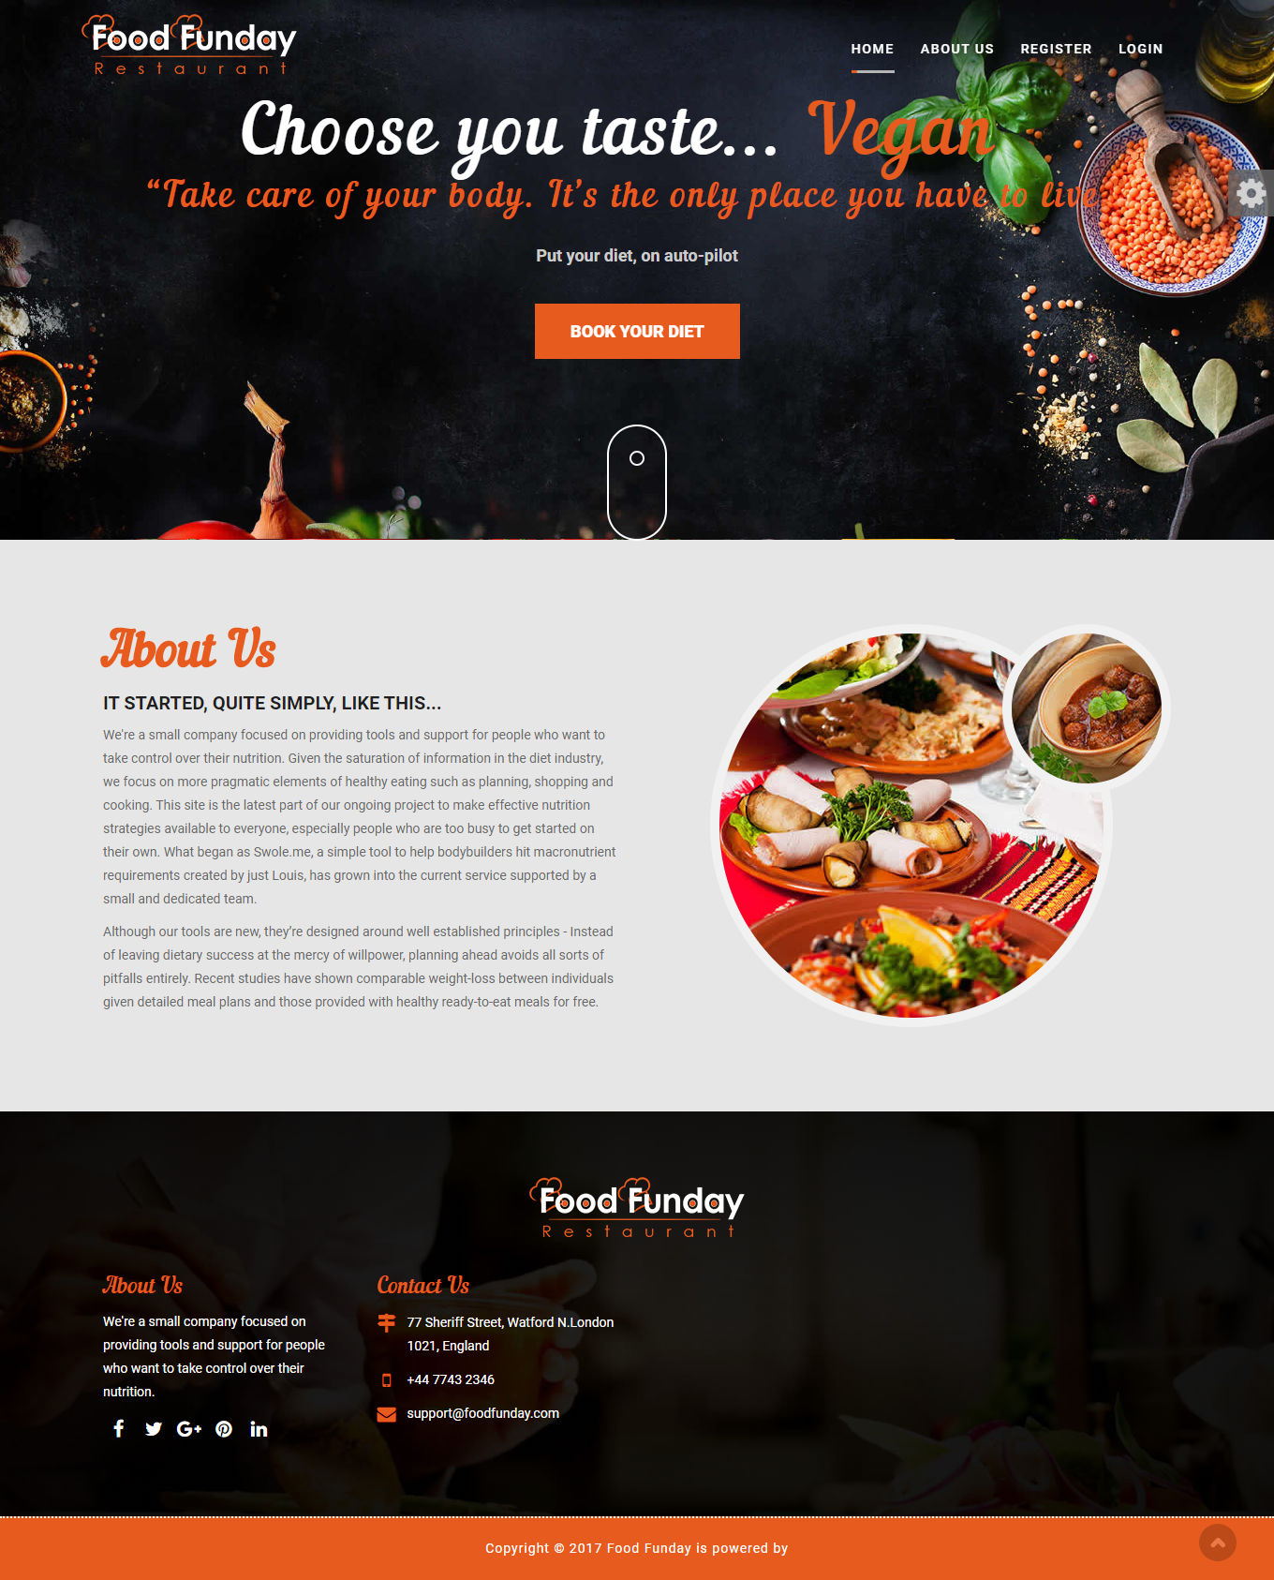

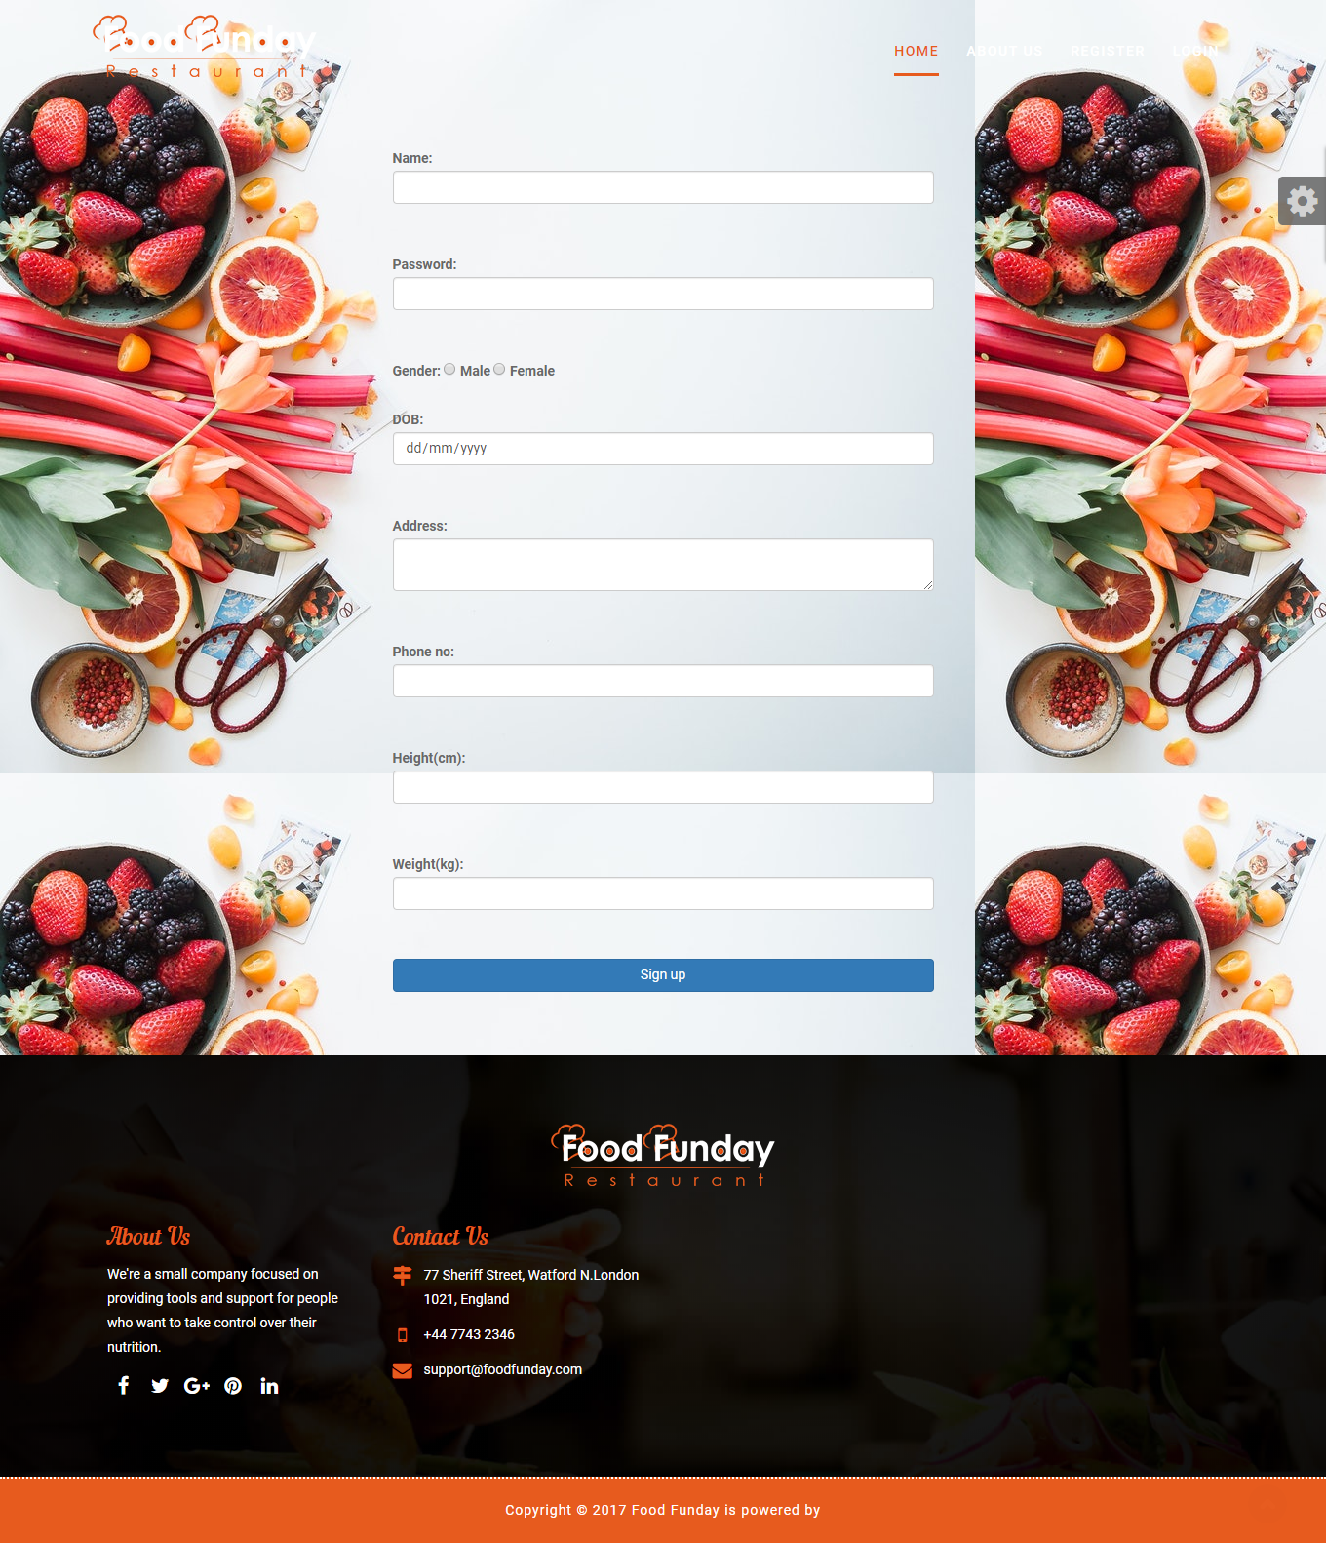

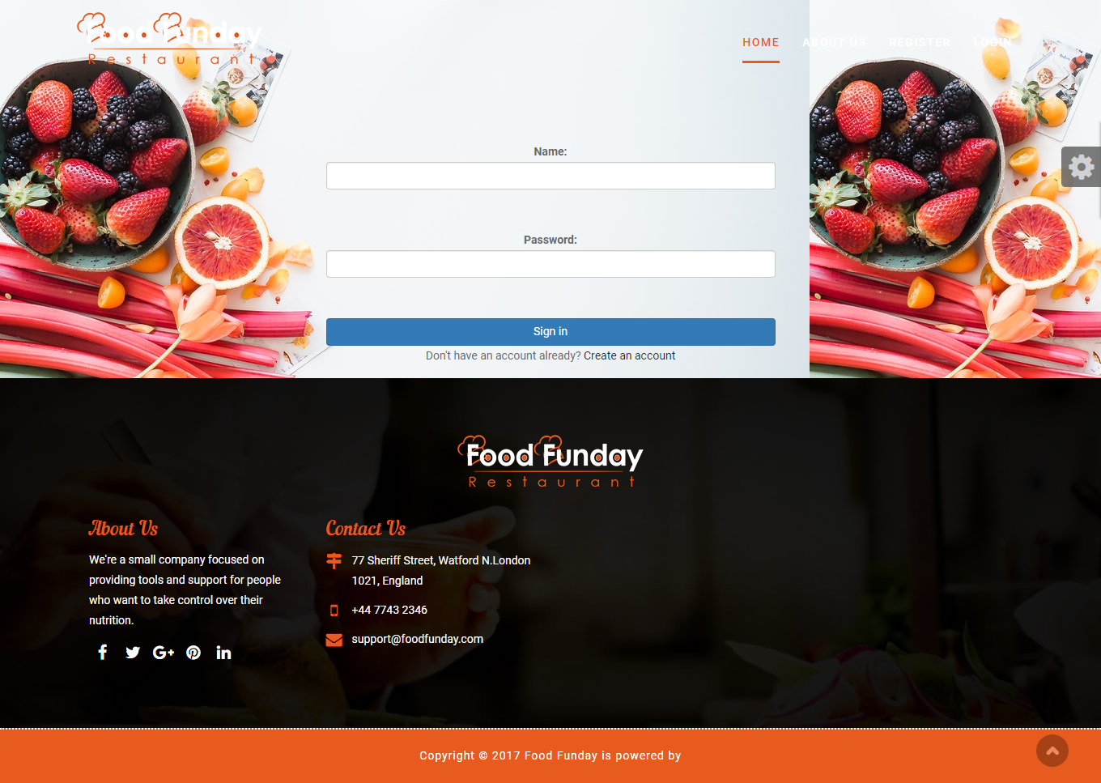

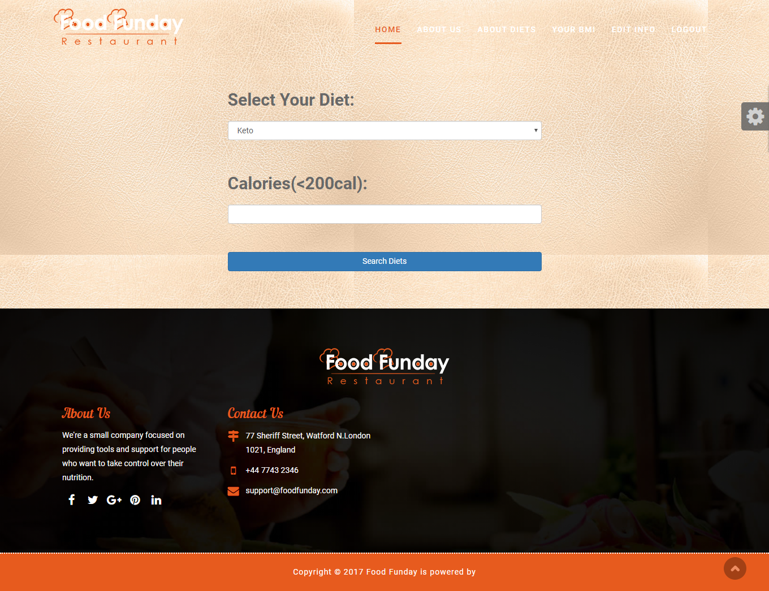

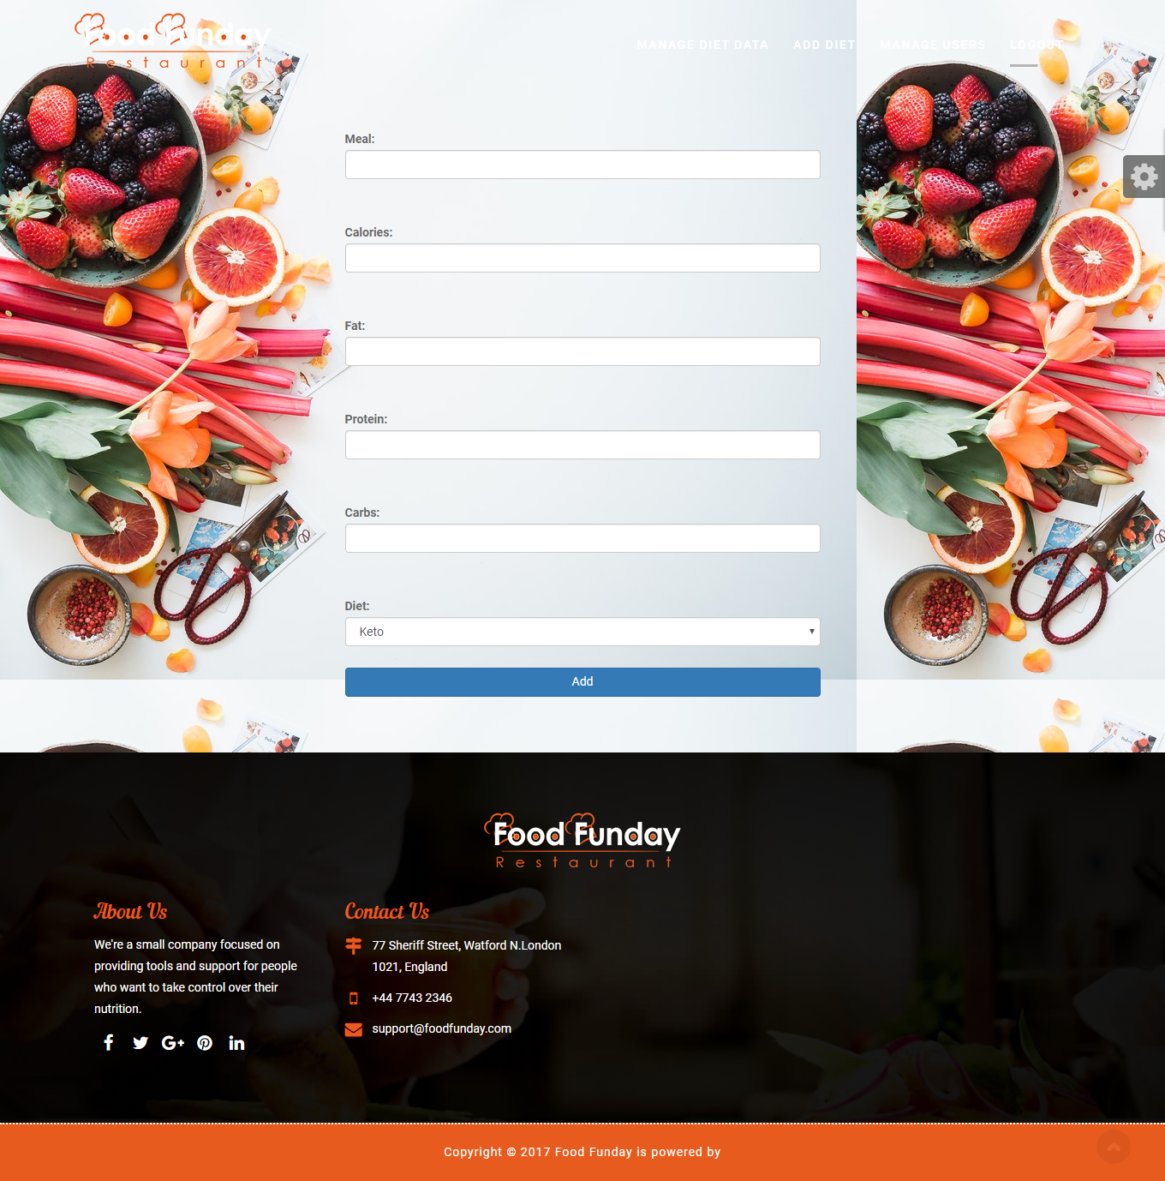

7.3 OUTPUT DESIGN

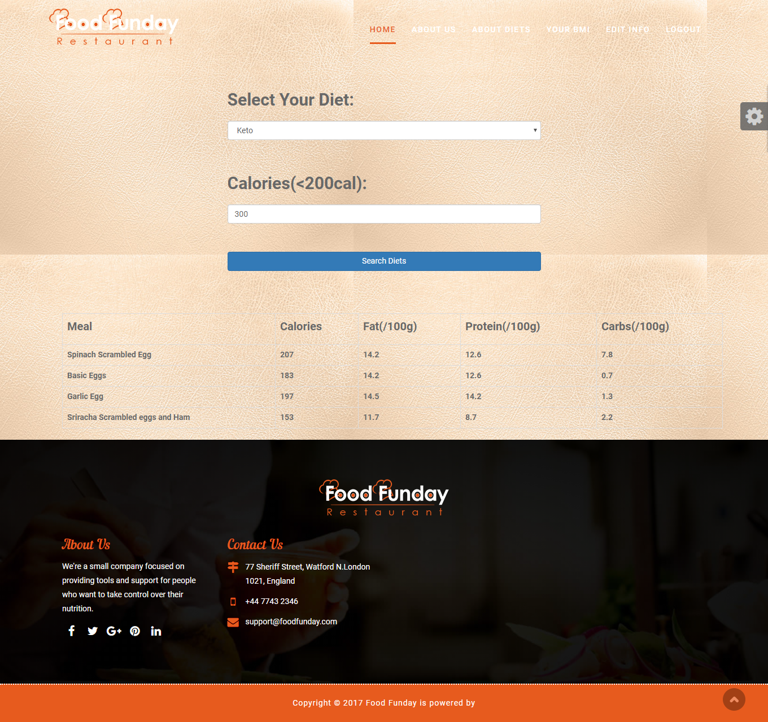

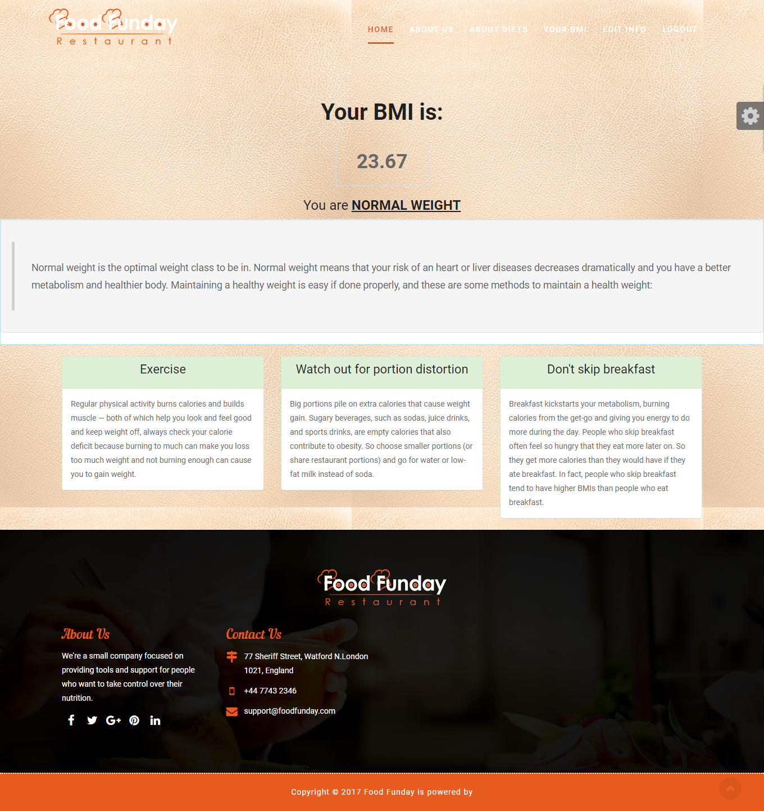

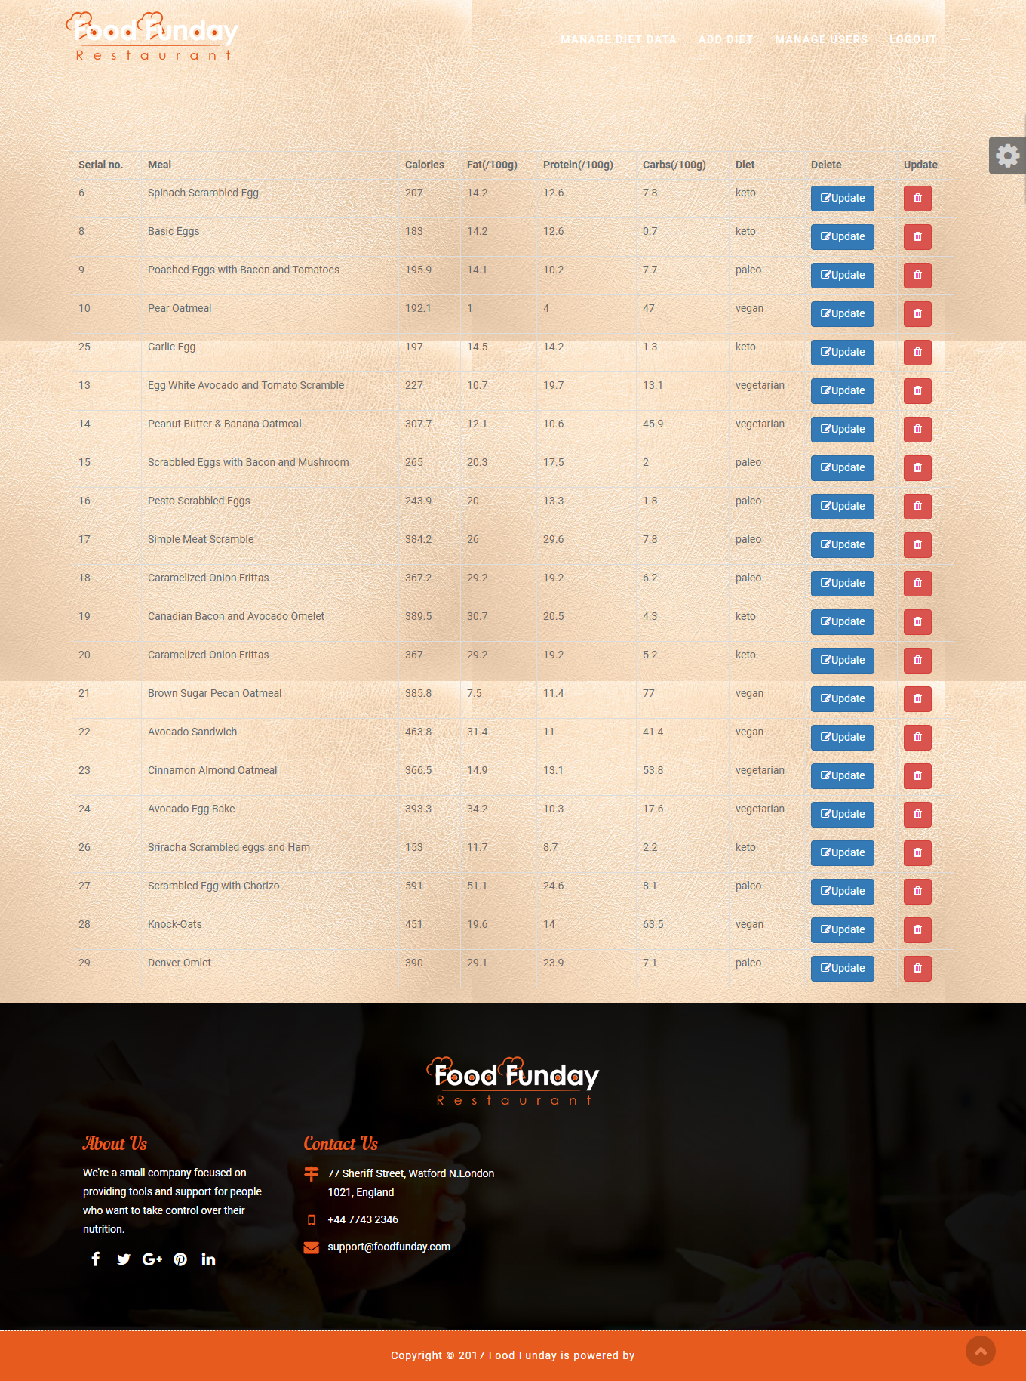

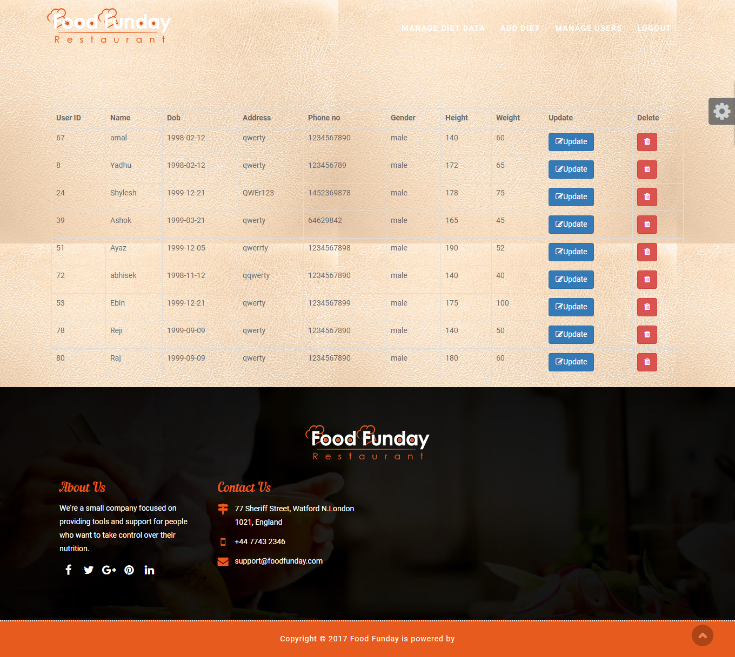

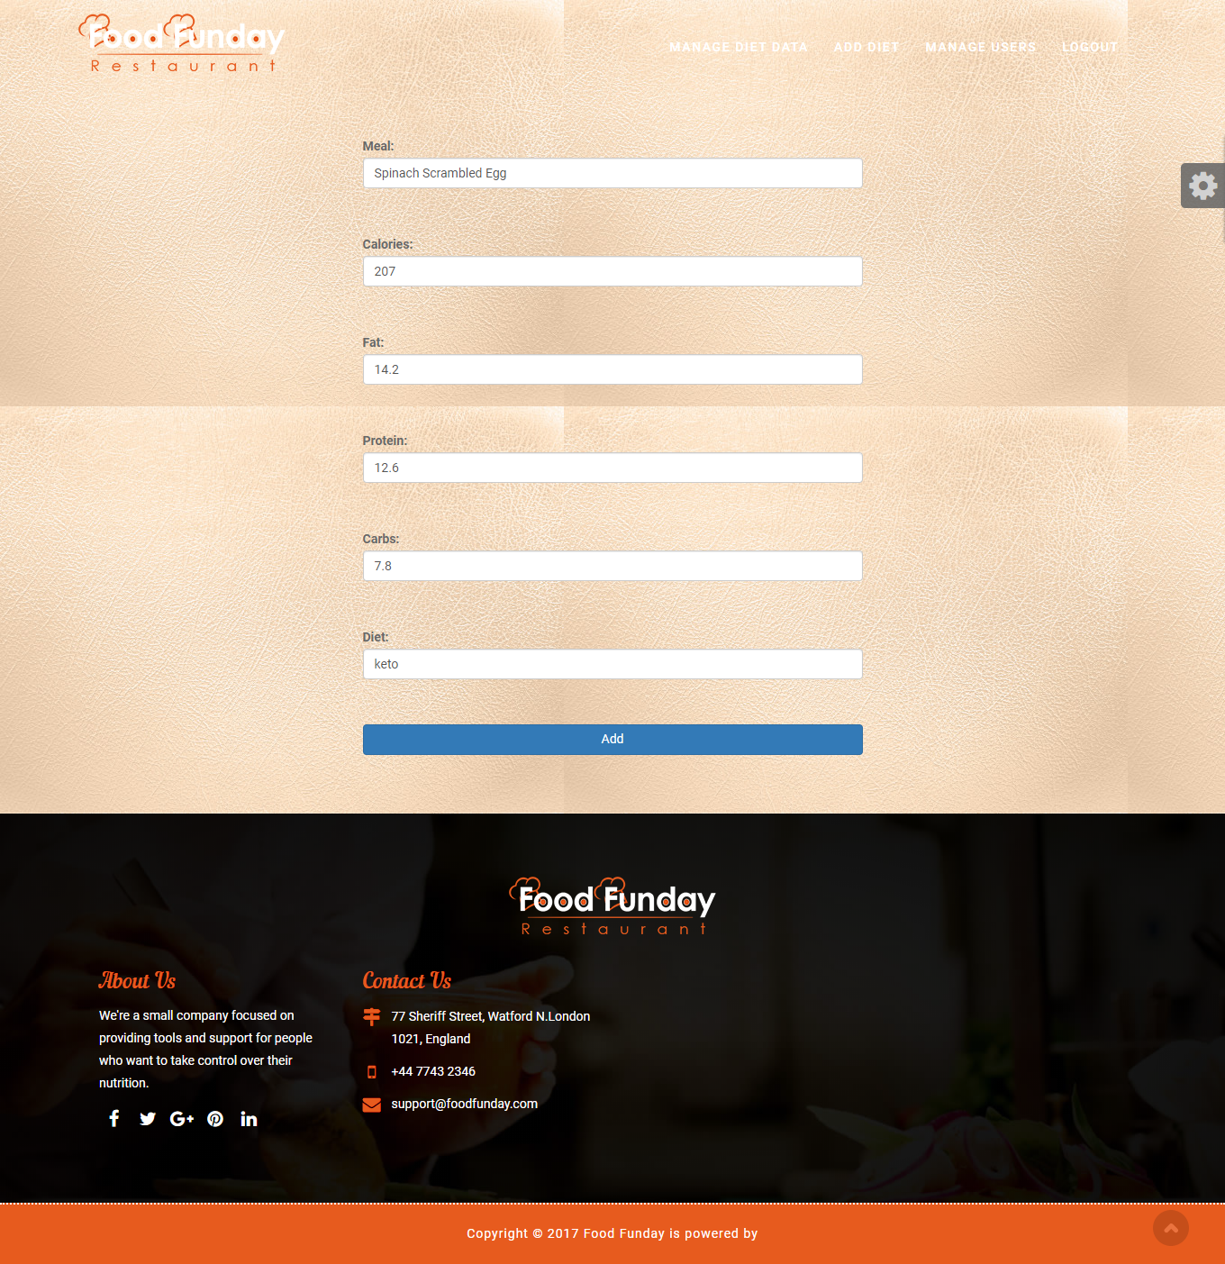

**8. CONCLUSION**

This system is very flexible and changes can be made without much difficulty. The further extension in the system can be made to submit more outputs to the management. The development of the system is based on the ideas that we got during the detailed study of the system.

Since sublime text 3, SQLyog is very flexible on the incorporate any modular program into the application. Thus, even after development phase is over, developing new applications and integrating in which the existing one is very easy. This project can be further enhanced by adding more features.

**9. BIBLIOGRAPHY**

References

Books

Structured Query Language – Ivan Bros

Website

[www.google.com](http://www.google.com/0082-jp/EEE-008)

https://www.w3schools.com

[https://www.eatthismuch.com](https://www.eatthismuch.com/)

<https://www.free-css.com>